Validation Rules

Exercise 1: Investigation

In this exercise, you create two maturity validation rule sets and observe their effects.

For the sake of reference, the five maturity validation levels in the base application, in order, are:

* Loadsave
* New Loss Completion
* Valid for ISO
* Send to external (system)
* Ability to pay

1. Inside the Claim Validation rule set, enter the following rule:

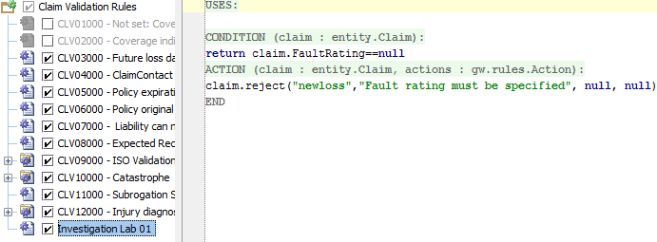

* 1. Will this rule raise a warning? If so, at what level?
  2. Will this rule raise an error? If so, at what level?

1. You do not need to test the rule at this point.
2. Inside the **Claim Validation Rule** rule set, enter the following rule:

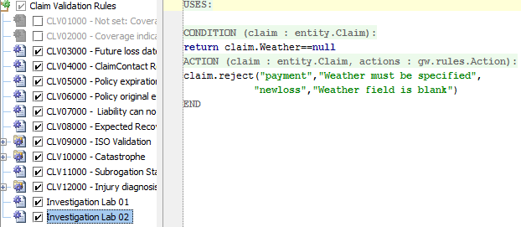

* 1. Will this rule raise a warning? If so, at what level?
  2. Will this rule raise an error? If so, at what level?

(You do not need to actually test the rule at this point.)

1. Create a new auto claim. On the **Loss Details** step, leave both the **Fault Rating** and **Weather** fields blank. Can you save the claim? Are both validation messages displayed?
2. Specify the **Fault Rating** as No fault and save the claim.
   1. What is the claim's validation level?
   2. How did the claim get beyond "new loss completion"?
   3. Why isn't the claim at "ability to pay"?
3. For the saved claim, attempt to set the Fault Rating back to "none selected". What happens? Why?
4. Using the claim's Actions menu, validate the claim at "new loss completion". Then, validate the claim at "ability to pay". Were the validation results the same?
5. Change the claim's **Weather** field to Clear. What is the claim's validation level now?
6. Disable the two rules you created at the start of the lab. (This prevents them from interfering with work you will do later in the course.)

Exercise 2: Configuration

Configure ClaimCenter to meet the following customer requirement from Acme Insurance.

Requirement 1: Validation for Claim Fields

Acme Insurance has the following requirements for claims:

Claim - new loss completion

* If the loss cause is either "Theft Audio or other parts" or "Theft of entire vehicle", there must be at least one police report listed. (Police reports are listed in the Metropolitan Reports list on the Loss Details page.)
* If the Fault Rating is "no fault" and the loss location's state is California (CA) or New York (NY), warn the user that the given state is not a "no fault" state, but let the claim be saved.

Claim - valid for ISO

* The claim must have a description. Highlight the field.

1. Write the claim validation rule(s) needed to enforce the behavior above.

Test Case 1

When you have completed your configuration, run the following test cases:

Remember to reload your configuration (Make Project) before testing.

1. Log on to ClaimCenter as Andy Applegate. Create a new auto claim. On step 4, make sure that:

* The **What Happened?** description field is blank.
* The **Loss Cause** is set to one of the theft options.
* The loss location **State** is set to California.
* There are no **Police Reports**.
* The **Fault Rating** is set to "No fault".

1. Attempt to save the claim. Verify that it cannot be saved because of the missing metro report, and the warning appears.

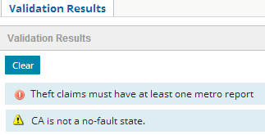

1. Add **a Police Report**. (You only need to specify the required values.) Verify that that claim can be saved, and that it is at new loss completion.

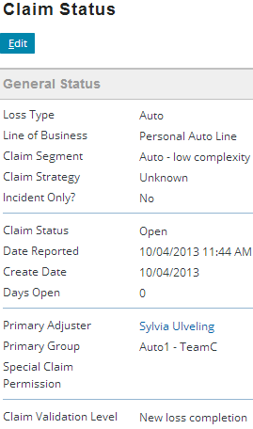

1. Use the **Validate Claim Only** menu action to validate the claim for New loss completion. Verify that the warning appears.

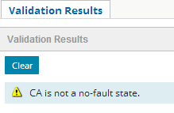

1. Then use the **Validate Claim Only** menu action to validate the claim for Valid for ISO. Verify that it states the description must be provided and that the description field is flagged in red.
2. Provide a description and save the claim. (You may also need to verify that coverage is not in question.) Verify that the claim is now at or beyond Valid for ISO.

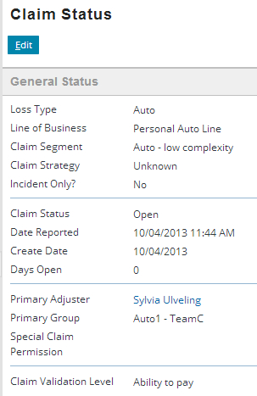

Bonus Task

Complete these requirements only if your instructor tells you to do so.

Requirement 2: Validation for Exposure Lists

Acme Insurance has the following requirements for exposures:

Sending exposure to outside systems (send to external)

* In the Other Carrier Involvement list, if a listed insurer has a contact (a name in the contact field), then the corresponding phone number field cannot be blank. (If it is, flag that field.)

1. Write the exposure validation rule(s) needed to enforce the behavior above.

Test Case 2

When you have completed your configuration, run the following test cases:

1. (To simplify testing, disable the Exposure Validation ISO rules.)
2. Attempt to create a new collision exposure in which there is at least one Other Carrier Involvement carrier with a contact and no phone number. Verify the exposure can be saved but that it cannot reach "send to external".
3. Add phone numbers to all Other Carrier Involvement carriers with contacts. Verify the exposure is now at or beyond "send to external".
4. Attempt to remove the phone number for an Other Carrier Involvement contact. Verify the change cannot be saved and that the field is flagged.

